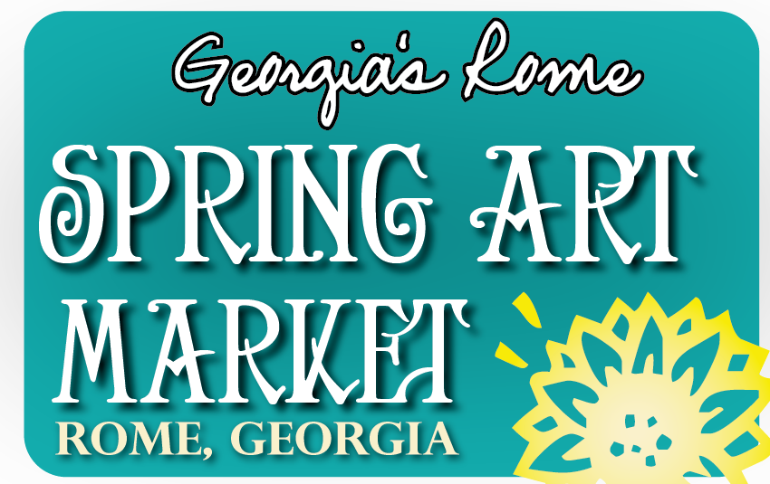

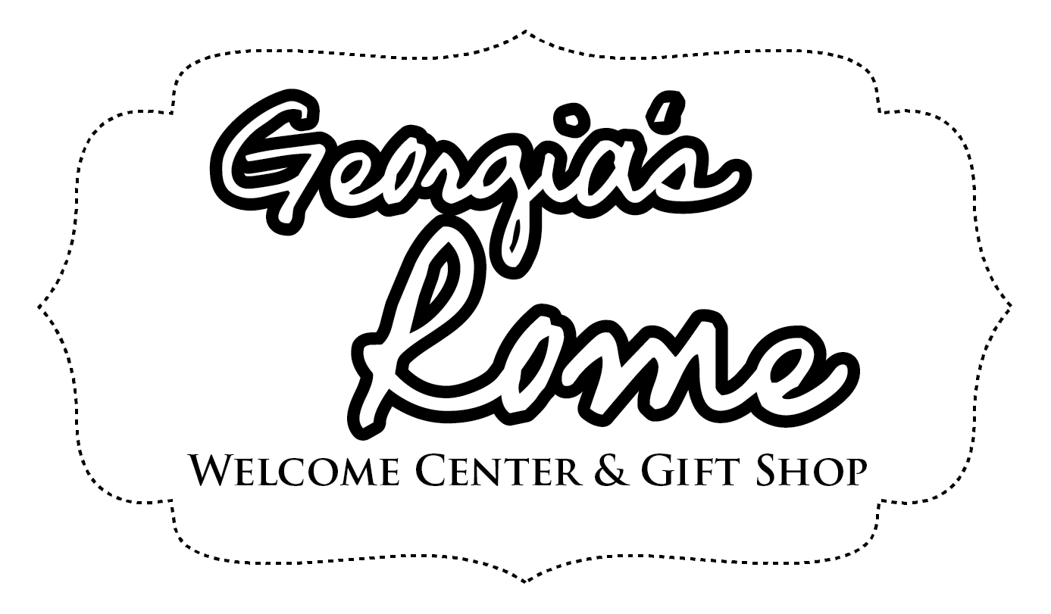
Saturday, April 5, 2025 – 10am-4pm
Sunday, April 6, 2025 – 10am-3pm

Rome Civic Center

APPLICATION FOR BOOTH SPACE
Company:_______________________________________________________________________________________________
(This name will appear on Spring Art Market signage and marketing materials)

Contact:__________________________________________________ Email Address__________________________________
(Please attach business card if available)

Phone Number___________________________ Facebook/Website (if applicable) ____________________________________
Mailing Address_________________________________________________________________________________________
******** All items in the Art Market are to be made by the artist*********
What kind of items do you make/sell? _______________________________________________________ ________________
Contact person and phone number during event: _______________________________________
________________________
Inside $100 Outside $50 ____________________________________________________
Do you need a table? ____________________
**For those needing power, you will be responsible for supplying your own extension cords.

***We limit the number of vendors in certain categories like jewelry, pottery, wood working and laser art. These categories fill up fast.
A non-refundable booth rental fee $50 outside or $100 inside will be required upon selection for Art Market. YOUR RESERVATION IS NOT SECURE UNTIL PAYMENT IS MADE. Included in your rental fee is an approximate 9-foot x 9-foot booth space and two chairs; an 8-foot table will be provided on a first-come, first-serve basis determined by your application/acceptance date. Cash or checks only, made payable to Greater Rome Convention & Visitors Bureau, will be accepted for payment. First time applicants are asked to provide four HIGH-RESOLUTION DIGITAL images representative of their work and of their logo (if applicable). These materials will be used in the marketing of the event through various channels. New Vendors please also provide a photo of your booth presentation at comparable events.

On Friday, February 7, 2025, the application will be opened to new vendors. All applications are due by Friday, March 21, 2025 at 5 p.m. Any applications received after Friday, March 21, 2025 will be $125.00. *****Remember your booth is not secured until your payment is made.

****I agree to stay set-up at the event until the official closing time each day. INITIALS: _______________________

To all vendors:
Before you add an artist to your booth the artist must be approved first by the Rome CVB. We try hard to limit the number of jewelry artist wood turners, etc. so everyone in the market can flourish. If we have too many of the same artist, it hurts everybody. Please help us help you by letting us know immediately if you are considering letting another artist in your booth.
Thank you,
Release
I acknowledge and agree to hold harmless the City of Rome, The Rome Convention & Visitor’s Bureau, and the Art Market committee from responsibility for injuries to any exhibitor, or for damaged or stolen work, or damage to displays by natural or willful causes. I agree to abide by the rules and regulations as set forth in the Art Market requirements. I understand that the Art Market and its authorities have the right to refuse admittance of any exhibitor and to request removal from the property should they not adhere to the Standards of Conduct set by the Art Market Committee and the City of Rome Government.

Signature: _____________________________________________________
Printed Name: _________________________________________________
Date: _________________________________________________________

Please complete the form and sign the release form. Return application and signed form to:
Charlene Mathis/Art Market
402 Civic Center Drive
Rome, GA 30161

